**BUDGET ANALYSIS AND REMINDER**

**INCREMENT #4**

**Submitted by**

**Group ID: MPG16**

**Raghavendra Chirumamilla (16187866)**

**Sandhya Sannapareddy (16181402)**

**Sampath Madineni (16185610)**

**Haricharana Kanamarlapudi (16186977)**

* **Objectives:**
* Applications allows user to set limit to the budget
* Application will automatically generate an alert message when the budget exceeds the limit.
* Application will generate the statically report of monthly or yearly expenses using bar graphs
* The users can edit or update their personal details in the settings.
* **Import Existing Services/ API:**

To view all expenses and budgets in a detail view we used graph API to display in a bar graph view.

* **Detail Design of Services:**
* **User Stories (using ScrumDo):**

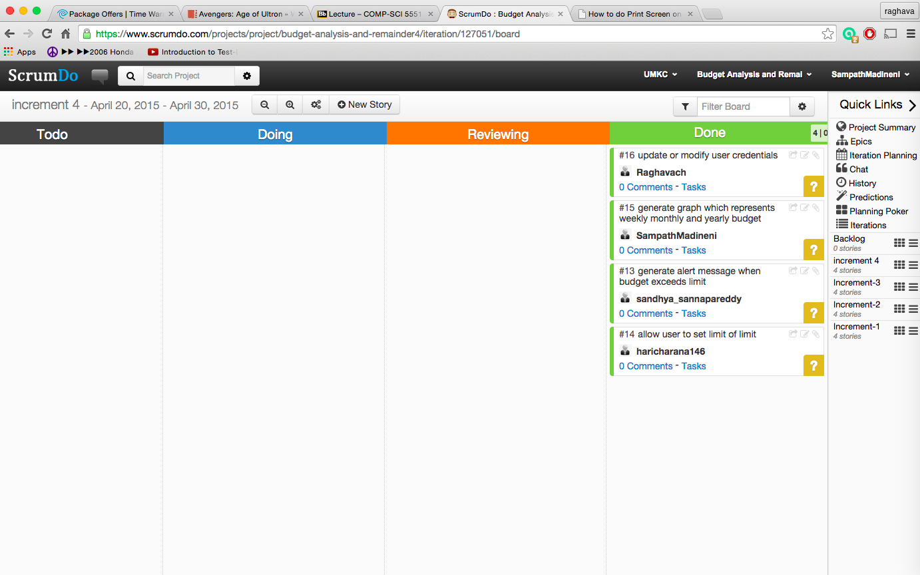

* **Sequence Diagram (using Visio):**

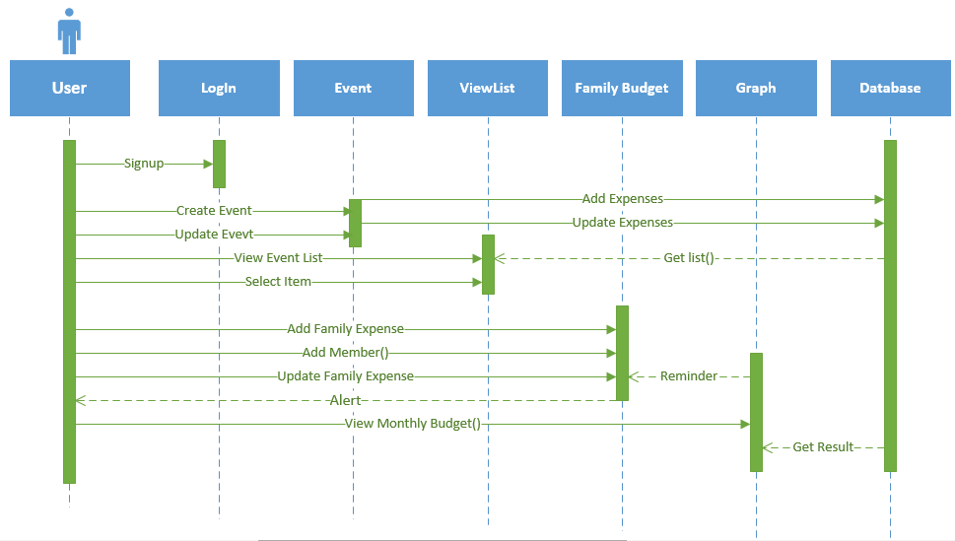

* **Class Diagram (using Visio):**

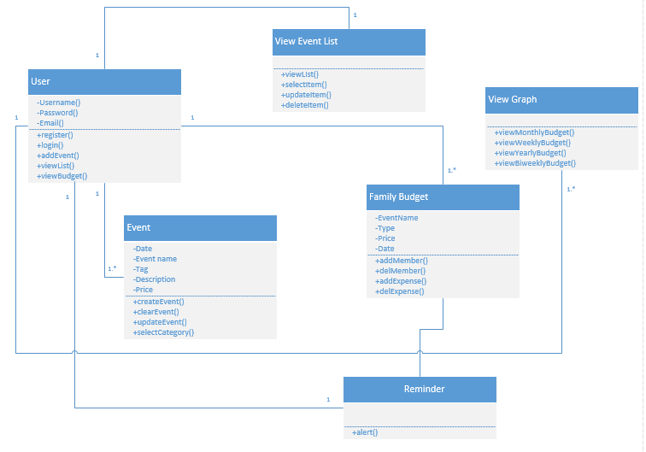

* **Service Description:-**

**Hardware Requirements:**

Dual Core processor or 1GHz processor

RAM: 512 MB

SD card: 50 MB

Device Type: Touch with LED screen

**Software Requirements:-**

Operating System: Android

Version: Ginger bread (2.3) or later

* **Implementation Implementation of user interface:**

When the user successfully logins into application a home screen will be displayed

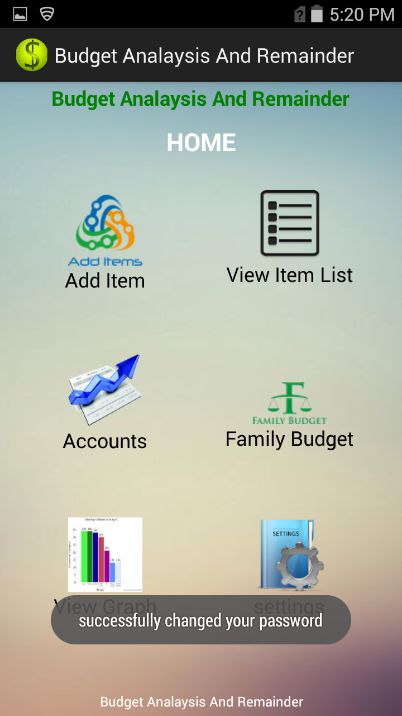

* Users have the facility to add budget of his/ her family members using multi login. User has facility to view expenses for separate users and also for the entire family

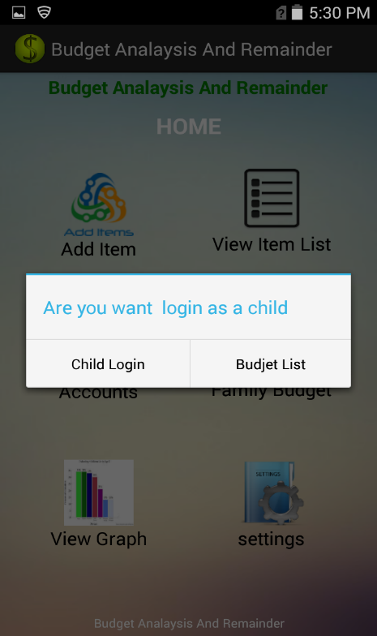

Only child budget can be viewed as

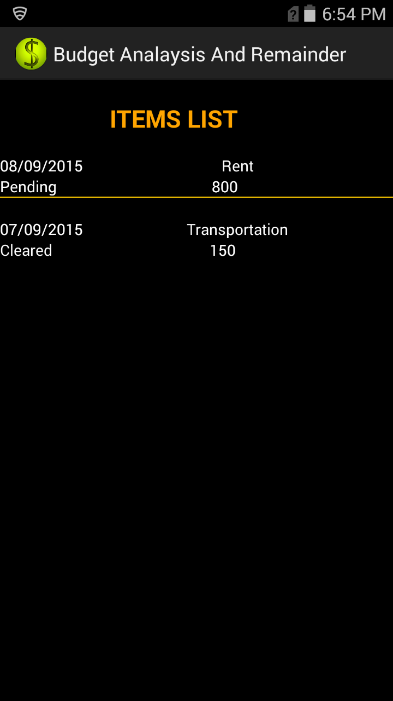

The entire family budget can be viewed as

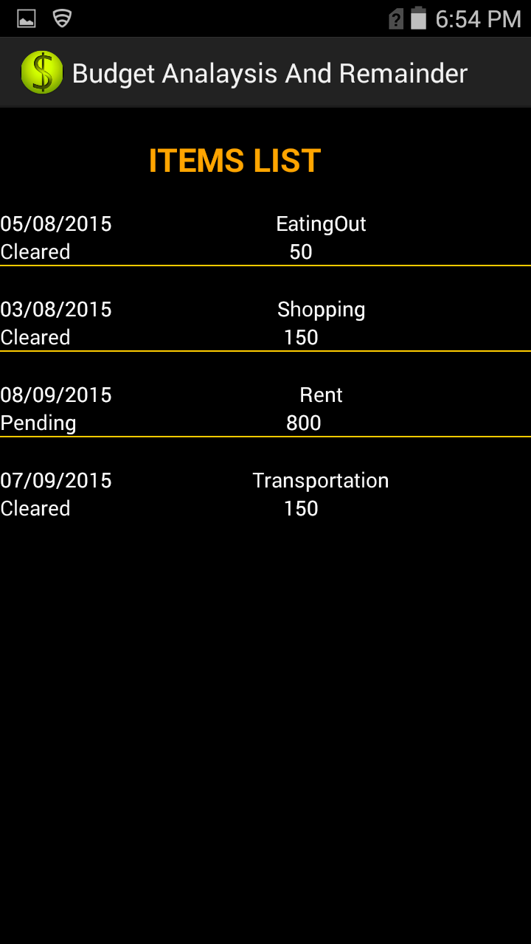

* When the budget of user exceeds the max value set by user it displays a message showing that user budget exceeded

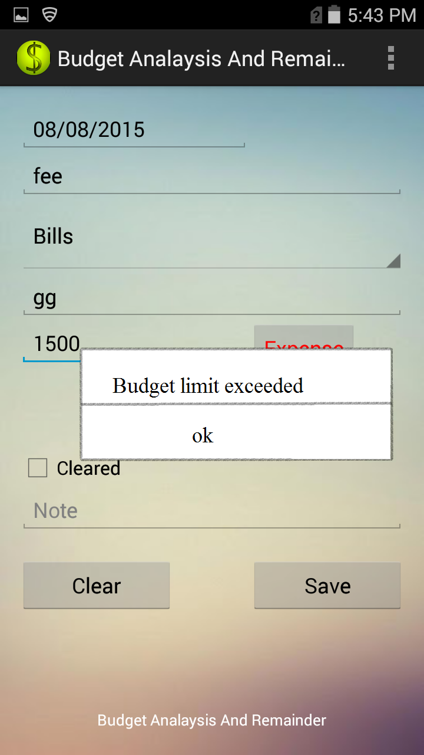

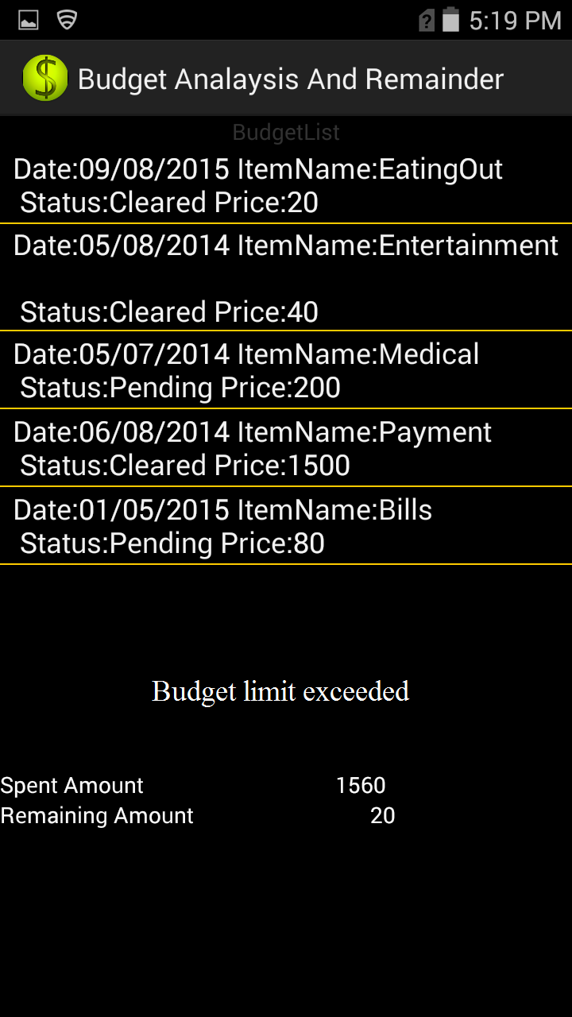

* To view all the expenses and budget details in a clear and quick view, he can select bar graph view from the home screen. It displays as

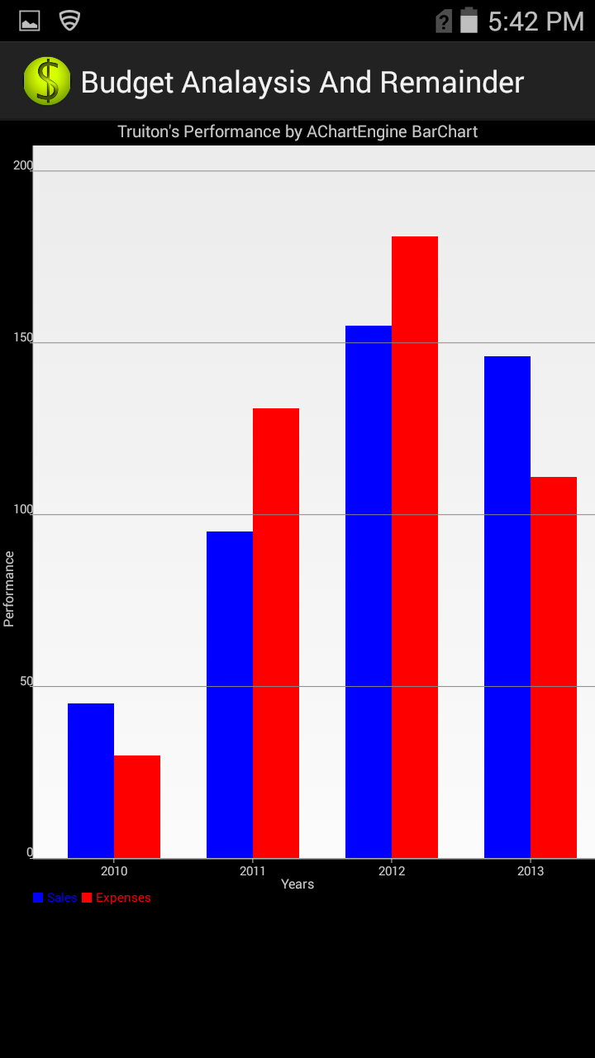

* User also has facility to manage his personnel details such as password change in order to secure his application.

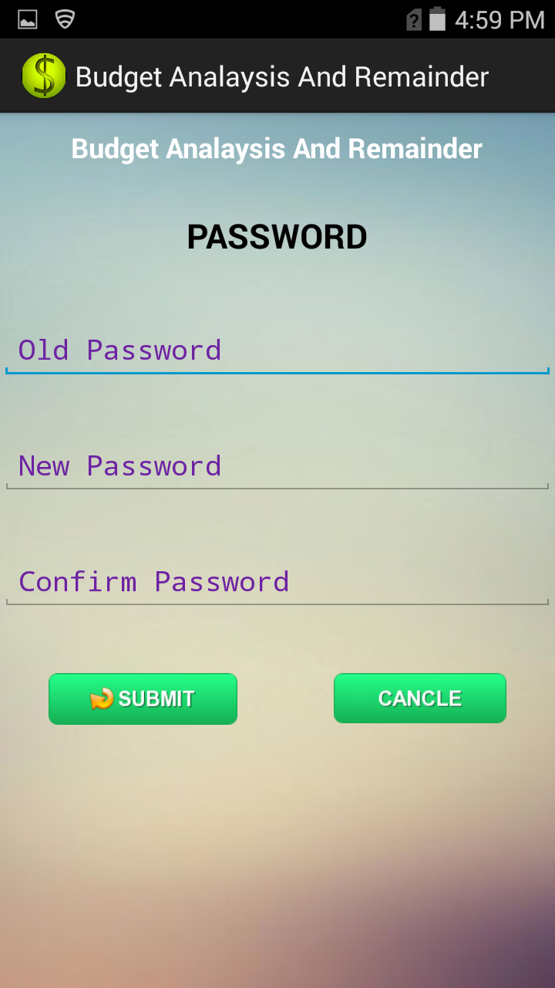

* The admin of the group has facility view, update and delete expenses of his own and also for family members

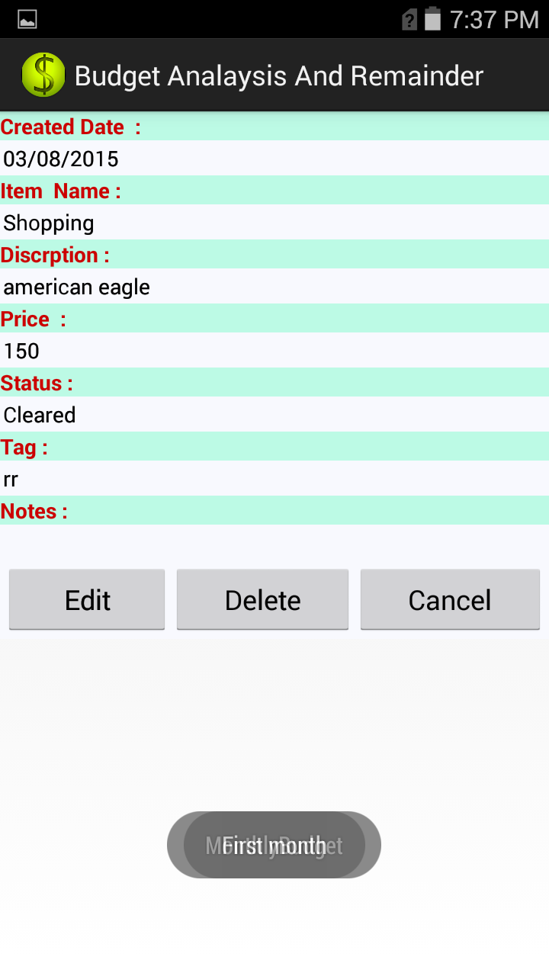

* **Testing:-**

**Positive test cases:-**

* User can successfully change his password from settings



* User can successfully update his expenses or delete if any modification needed.

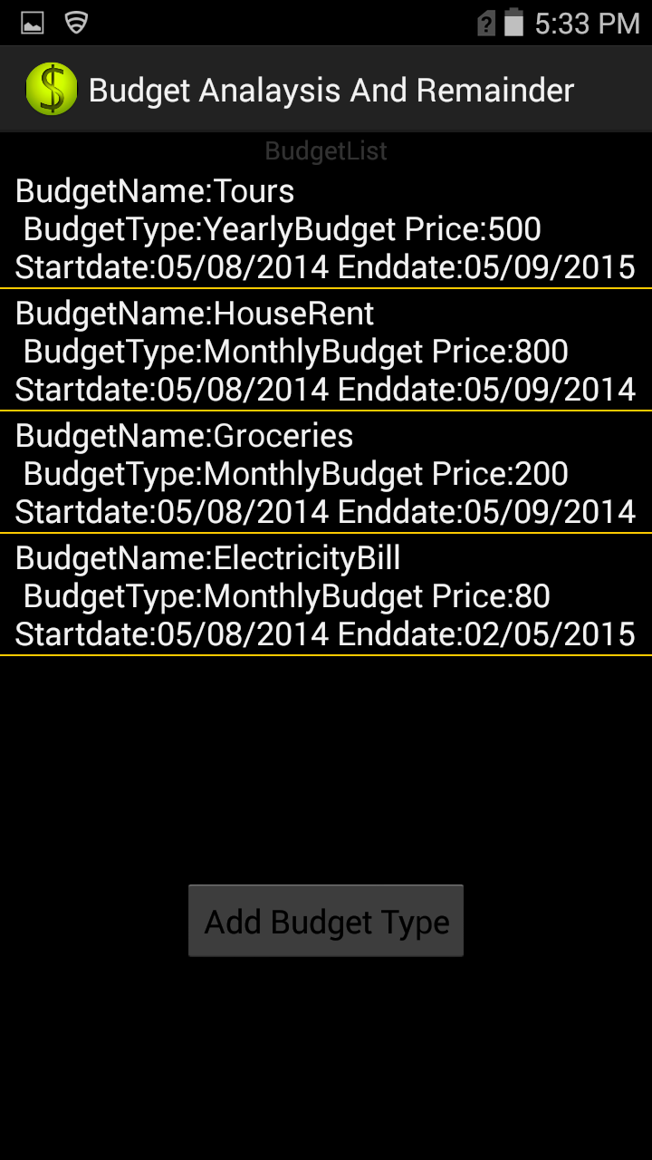

**Negative test cases:-**

* If user enters wrong current password or enters password without following proper rules then it displays error message.

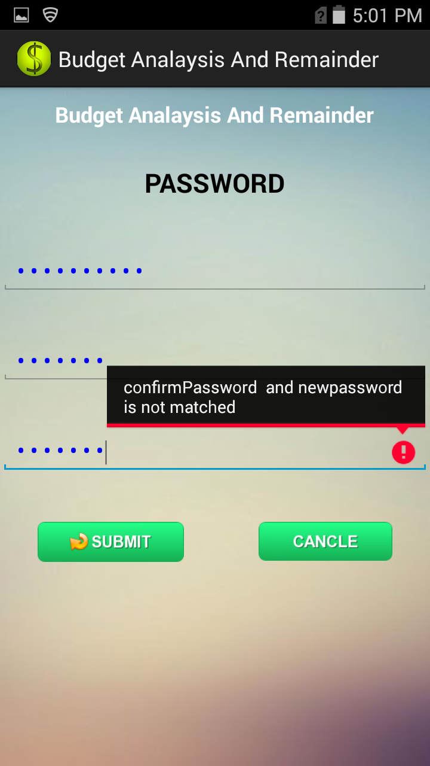

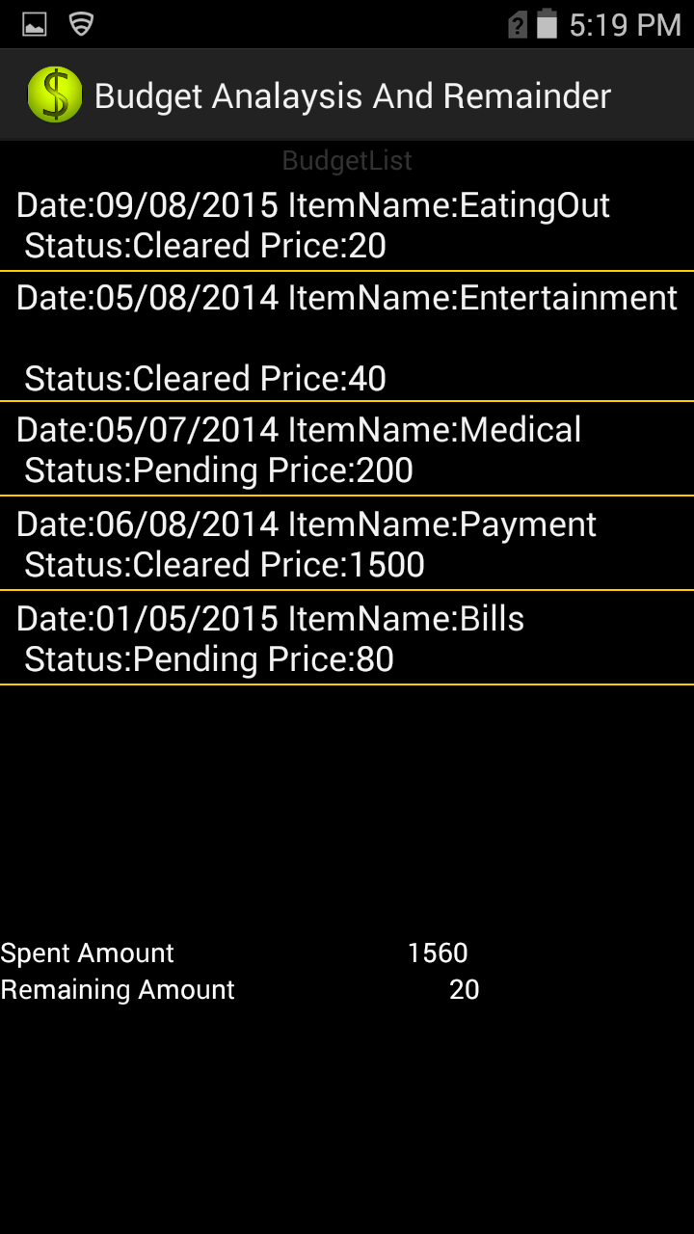

* **Deployment:**
  + **ScrumDo:**

<https://www.scrumdo.com/projects/project/budget-analysis-and-remainder4/iteration/127051>

* + **GitHub:**
* **Project Management:**

**Work completed**

**Description:**

1. User sets limits to the budget and also he can view, update and delete the existing budget
2. Generate an alert message when the expenses of the user exceeds the budget limit
3. Generate a bar graph for clear representation of the weekly, monthly and yearly budget.
4. User can edit or update his/ her profile in the settings such as change password.

**Responsibility (task, person):**

*Sandhya Sannapareddy*:- Generating an alert message when the budget exceeds the limit.

*Harichrana Kanamarlapudi****:*** Allows users to set limit to the budget.

*Sampath Madineni****:*** Generating the graph to represent the monthly or yearly data.

*Raghavendra Chirumamilla****:-*** Allows users to update or modify the personal info in the settings.

**Time Taken:** Two weeks ( 15 days)

**Contribution:**

Sandhya Sannapareddy: 25%

Haricharana Kanamarlapudi: 25%

Sampath Madineni: 25%

Raghavendra Chirumamilla: 25%

* **Issues/Concerns:**
* Difficulty in generating the graphs with accurate values using the API’s
* Generating the alert when expenses exceeds the user budget limit.